SQL Codes

**1, 2** : This is a fast way to create table for movie logging. The first query table creates the table and the second one clears the table.

**Codes:**

create Table Deleted_Movie as (select * from Movie where id=1);

truncate Deleted_Movie;

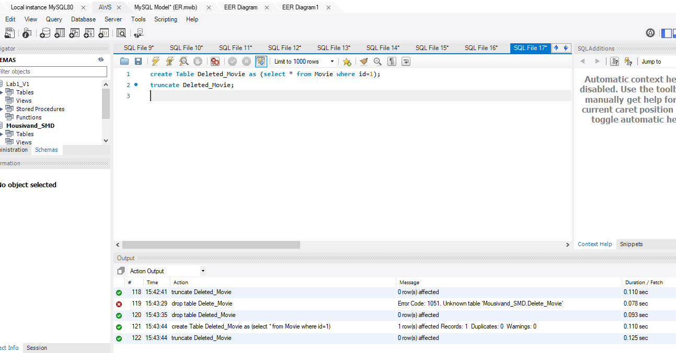

**3**:This query is to make sure that no user can have more than 5 accounts and adds a constraint

**Code**:

ALTER TABLE Account

ADD CHECK (Account_Number<=5);



**4**: This query gives everything about 10 animation movies with highest Rating in the descending order

**Code:** select * from Movie where Genre like '%Animation%' or Genre like '%animation%' order by Rating desc limit 10 ;

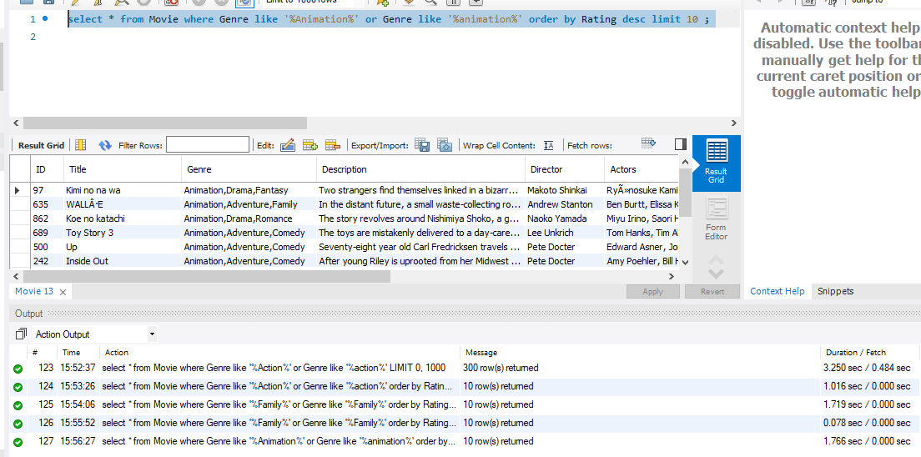

**5**: Here by “set autocommit” , “commit” and “rollback”, transaction is created to have either user added and account number one dedicated to him , or neither the user is added nor the first account is created for him .

**Code:**

set autocommit=0;

insert ignore into User values ('Roberto_Baggio18' , 'Roberto', 'baggio', '3435112','18, Rome St, Milan, Italy');

rollback;

insert ignore into User values ('Roberto_Baggio18' , 'Roberto', 'baggio', '3435112','18, Rome St, Milan, Italy');

insert into Account values (1, MD5('Baggio_Password') , 'Roberto_Baggio18');

commit;

set autocommit=1;

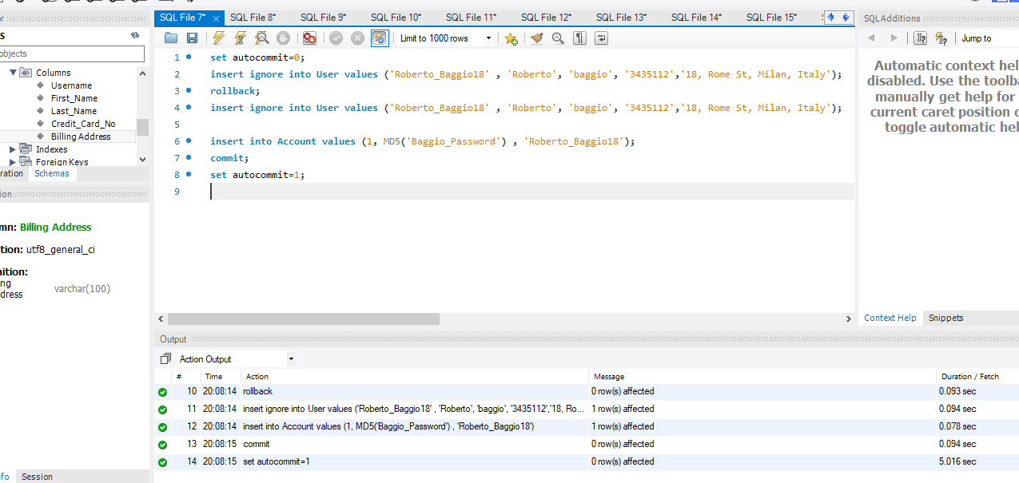

**6**: This Query creates an index to improve speed searching for a movie based on its title using Btree data structure and algorithms. First it removes the created index, the defined it again with adding Btree as the algorithm.

drop index title_index on Movie;

CREATE INDEX title_index ON Movie (Title) USING btree;

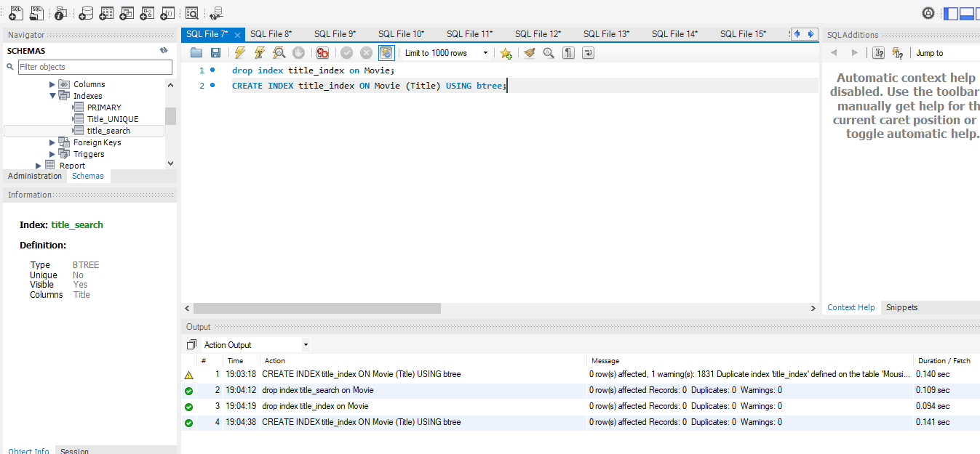

**7**: This query shows the number of accounts associated with User (Ramin Mousivand).

**Code**: select count(A.Account_Number) as 'Number of Accounts' from Account A, User U

where U.First_Name="Ramin" AND U.LAST_NAME='Mousivand' AND A.Username=U.Username;

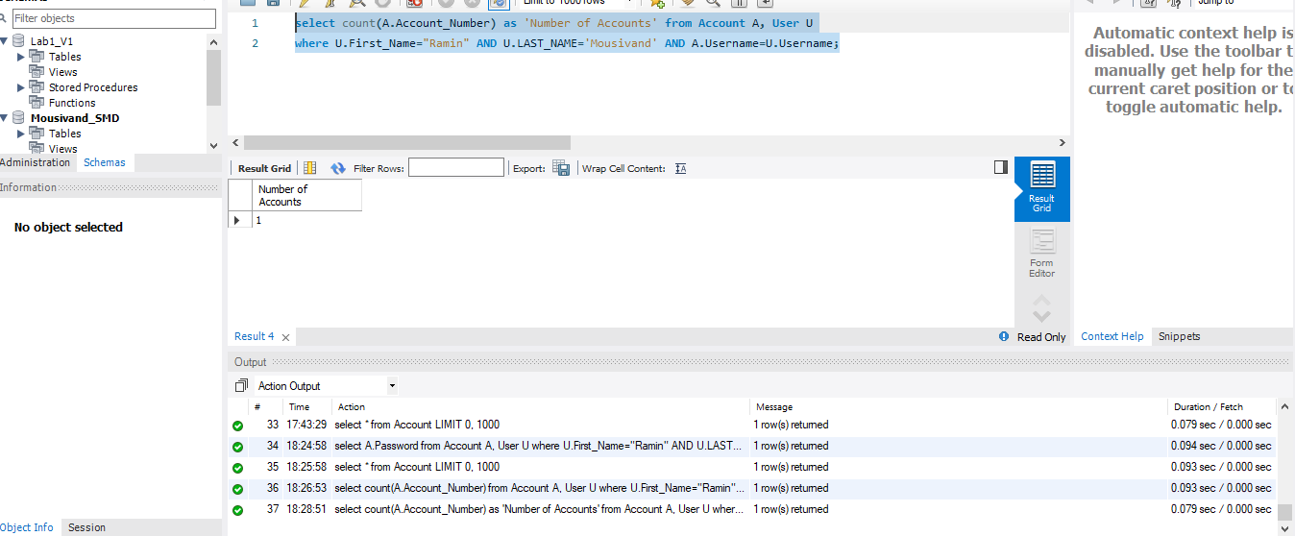

**8:** This query creates a view that holds username and credit cards of users in California

CREATE VIEW CA_Credit_Card AS

SELECT Username, `Credit_Card_No`

FROM User

where User.`Billing Address` like '%California%' or `Billing Address` like '%CA%';

select * from CA_Credit_Card;

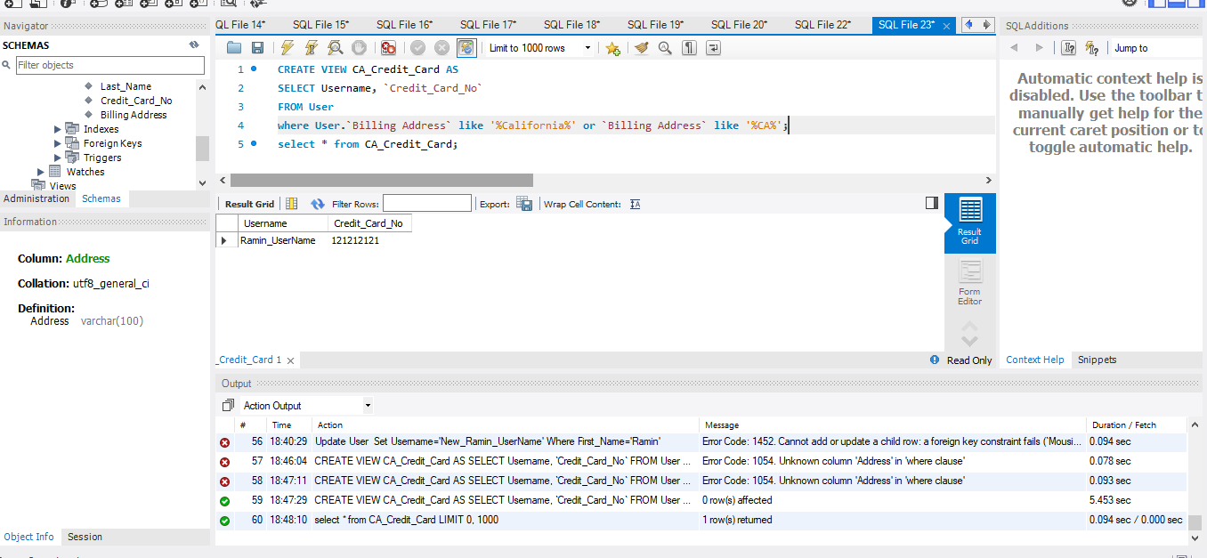

**9**: This query is used to update User (Ramin Mousivand)’s billing address.

update User

set `Billing Address`='232 Sunset St, San Francicso, CA, US'

where Username='Ramin_Username';

select * from User

where Username="Ramin_Username";

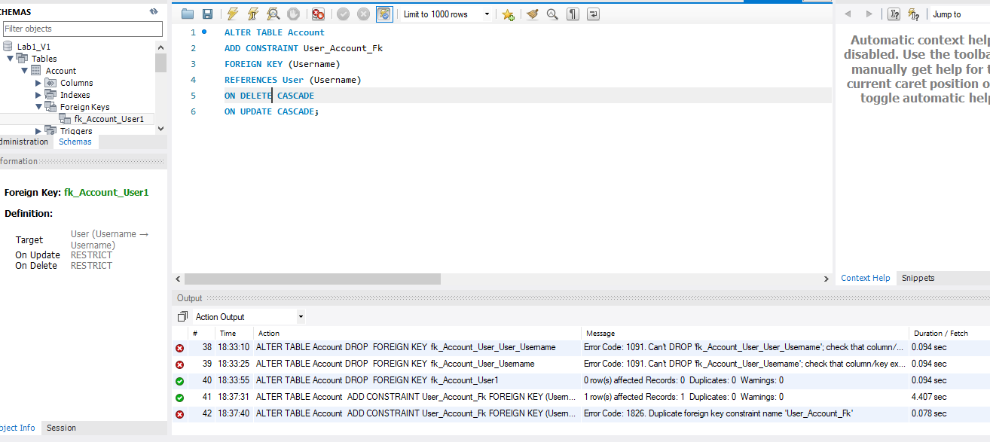

**10**: Find 5 directors with most number of works.

**Code:** select Director, count(*) as 'Number of Movies' from Movie

group by Director

order by count(*) desc

limit 5;

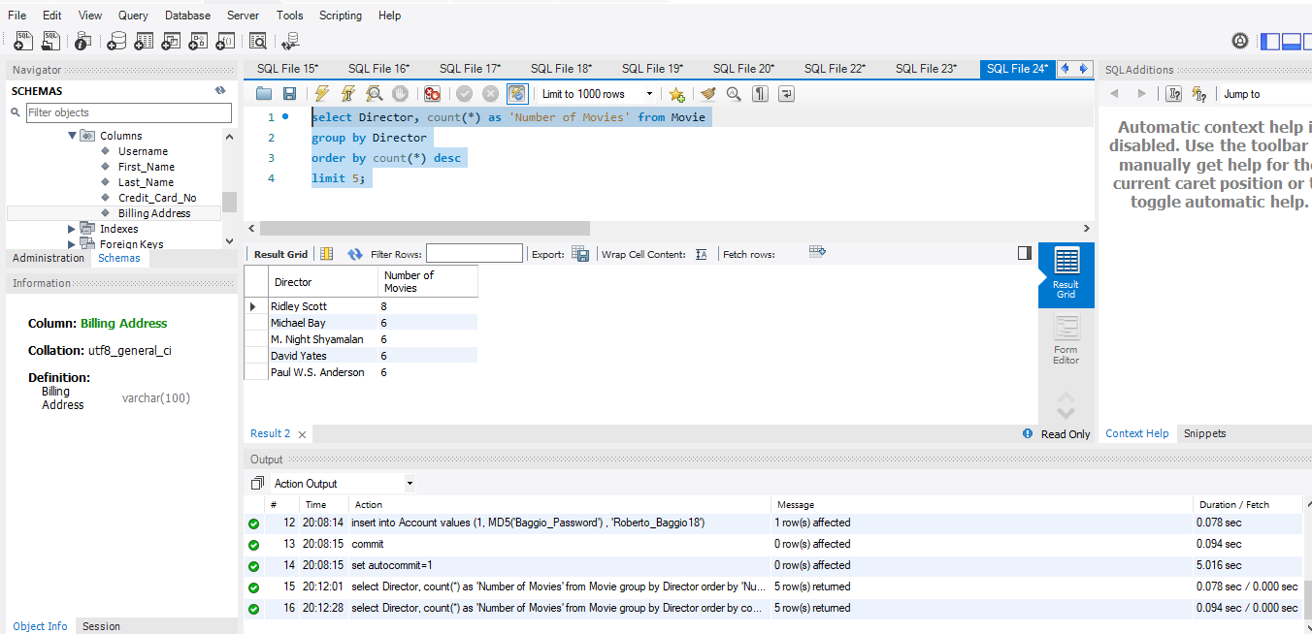

**11:** This is to get info regarding the table Deleted_Credit_card.

**Code:** describe table Deleted_Credit_card;

